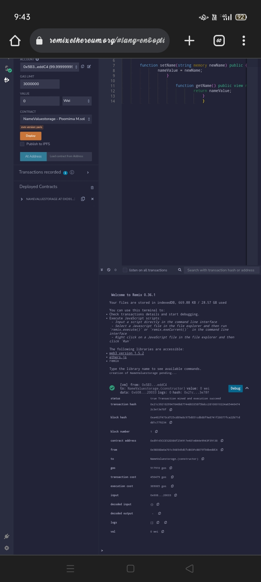

9:43

remix ethereum.org/#lang=en&opti

ACCOUNT

6

Ox5B3...eddC4 (99.99999999

7

8

GAS LIMIT

**3000000**

VALUE

0

9

10

11

12

13

Wei

14

CONTRACT

NameValuestorage - Poornima M.sol +

evm version: paris

Deploy

Publish to IPFS

At Address

Load contract from Address

Transactions recorded 10

Deployed Contracts

> NAMEVALUESTORAGE AT 0XD91....

=

>

+

60

41 (92)

function setName(string memory newName) public { nameValue newName;

function getName() public view return nameValue;

}

listen on all transactions

Search with transaction hash or address

Welcome to Remix 0.36.1

Your files are stored in indexedDB, 669.88 KB / 28.57 GB used

You can use this terminal to:

• Check transactions details and start debugging.

• Execute JavaScript scripts:

- Input a script directly in the command line interface

- Select a Javascript file in the file explorer and then run remix.execute()' or `remix.exeCurrent()' in the command line interface

*- Right click on a JavaScript file in the file explorer and then*

click 'Run'

The following libraries are accessible:

• web3 version 1.5.2

• ethers.js

• remix

Type the library name to see available commands. creation of NameValuestorage pending...

[vm] from: 0x5B3...eddC4

to: NameValuestorage.(constructor) value: 0 wei data: 0x608...20033 logs: 0 hash: 0x21c...3e78f

status transaction hash

true Transaction mined and execution succeed

Debug

A

**Ox21c3921029947646b87744d63358f5bdcc2810001022405440474**

2c3e13e78f

block hash

**block number**

**contract address**

to

Oxa402f473cd725cd89a8c975d051cdb88f9a8741f28077fca22b71d

dd1c779234 D

1

Oxd9145CCE32D386f254917e481e844e9943F39138

Ox58380a6a701c568545dcfcB03FCB875f50beddc4

NameValuestorage.(constructor)

**gas**

317910 gas

transaction cost

450479 gas

execution cost

309005 gas

**input**

**Ox008...20033**

decoded input

decoded output

[

**logs**

[] @

O

O wei

о